**Assignment – 8**

Assigned To = All 10 Class Student

Note: All Questions are compulsory to attempt

**Chapter = Introduction to Trigonometry**

**Submission Date = See on portal MM = 30**

Q1. **In a △ ABC, right-angled at B, AB = 24 cm , BC = 7 cm. Determine**

**(i) sin A , cos A (ii) sin C, cos C**

Q2. **If cot θ = 7/8, evaluate**

**(i)   (1+sin θ)(1–sin θ)/ (1+cos θ)(1–cos θ)**

**(ii)  cot2θ**

Q3. **Prove that:**

**(i) tan 20° tan 35° tan 45° tan 55° tan 70° = 1**

**(ii) sin 48° sec 48° + cos 48° cosec 42° = 2**

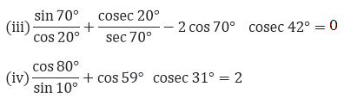

Q4. R D Sharma Solutions For Class 10 Maths Chapter 6 Trigonometric Identities ex 6.2 - 10

Q5. Prove the Following

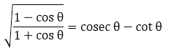

1. **sin θ/ (1 – cos θ) = cosec θ + cot θ**
2. **(cosec A – sin A)(sec A – cos A)(tan A + cot A) = 1**

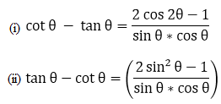

1. **(cos2 θ/ sin θ) – cosec θ + sin θ = 0**

R D Sharma Solutions For Class 10 Maths Chapter 6 Trigonometric Identities ex 6.1 - 20

1. **cosec6θ = cot6θ + 3cot2θ cosec2θ + 1**

R D Sharma Solutions For Class 10 Maths Chapter 6 Trigonometric Identities ex 6.1 - 22

R D Sharma Solutions For Class 10 Maths Chapter 6 Trigonometric Identities ex 6.1 - 35

1. **cosec6θ = cot6θ + 3cot2θ cosec2θ + 1**

R D Sharma Solutions For Class 10 Maths Chapter 6 Trigonometric Identities ex 6.1 - 41

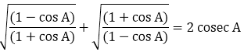

R D Sharma Solutions For Class 10 Maths Chapter 6 Trigonometric Identities ex 6.1 - 65